MAVIS Faster Staging
Technical Design Document for D0010 and D0150

Danie Selvaraju

14-01-2026
Version 0.1


Document Reviewers
Name | Role | Date
Peter Waymont | Income Services Manager
Neal Medley | Income Processes and Projects Manager (Systems)

Document Approvers
Name | Role | Date
Peter Waymont | Income Services Manager

Document Issued to
Name | Role | Date
David Yeoman

Version History
Version | Date | Comment | Name
0.1 | 14-01-2026 | Initial version | Danie Selvaraju

Reference Documents
Reference document | Owner | Sharepoint
Mavis Faster Staging Requirements Document | Danie Selvaraju
Mavis Faster Staging Validation Configuration Document | Danie Selvaraju

1. Document Reviewers 2
2. Document Approvers 3
3. Document Issued to 3
4. Version History 3
5. Reference Documents 3
6. Introduction 6
6.1 Purpose of this document 6
6.2 Scope and approach of the document 6
6.3 Target audience 6
7. Architecture Overview 7
7.1 System Architecture 7
7.2 Design Principles 8
8. Component Design 8
8.1 Package Structure 8
8.1.1 PKG_DTC_VALIDATION (Generic Validation Package) 8
8.1.2 PKG_DTC_D0010 (D0010 Flow Package) 8
8.1.3 PKG_DTC_D0150 (D0150 Flow Package) 9
8.2 Generic Validation Framework 9
8.2.1 Two-Stage Validation Approach 9
8.2.2 Hierarchical Validation Logic 10
8.2.3 Field Validation Engine 11
8.3 D0010 Flow Design 11
8.3.1 Data Structure 11
8.4 D0150 Flow Design 11
8.4.1 Data Structure 11
8.5 6. Data Model 12
8.5.1 6.1 D0010 Staging Tables 12
8.5.2 6.2 D0150 Staging Tables 13
8.6 6.3 Configuration Table 14
9. Process Flows 16
9.1 Overall Process Flow 16
9.2 Stage 1 Validation Flow 17
9.3 Stage 2 Validation Flow (Per Line) 18
10. Hierarchical Validity Propagation 19
11. Error Handling 19
11.1 Error Codes 19
12. Configuration Management 23
12.1 Configuration Retrieval 23
12.2 Validation Configuration Structure 24
13. EWAY Changes 24

Introduction
MAVIS, Customer management application, receives D-Flows from the Industry. Two Data flows D0150 and D0010 are high in volumes and the current Datastage staging process is unable to handle the volume due to design constraints. This document provides a solution which enables faster staging of these Data flows mitigating the backlogs of these flows and enable business to access the data without delay. The design is aimed at developing reusable components that can be used for migration of additional Data flows in the future. This design can be viewed as a strategic step towards replacing Datastage.

Purpose of this document

This document provides low level design for Mavis Faster Staging

Scope and approach of the document
- Changes to the MAVIS D-Flow Staging process related to D0010 and D0150

Target audience
The target audience for this document is personnel who are directly or indirectly associated with MAVIS.

Architecture Overview

System Architecture
The system follows a layered architecture with clear separation of functions:
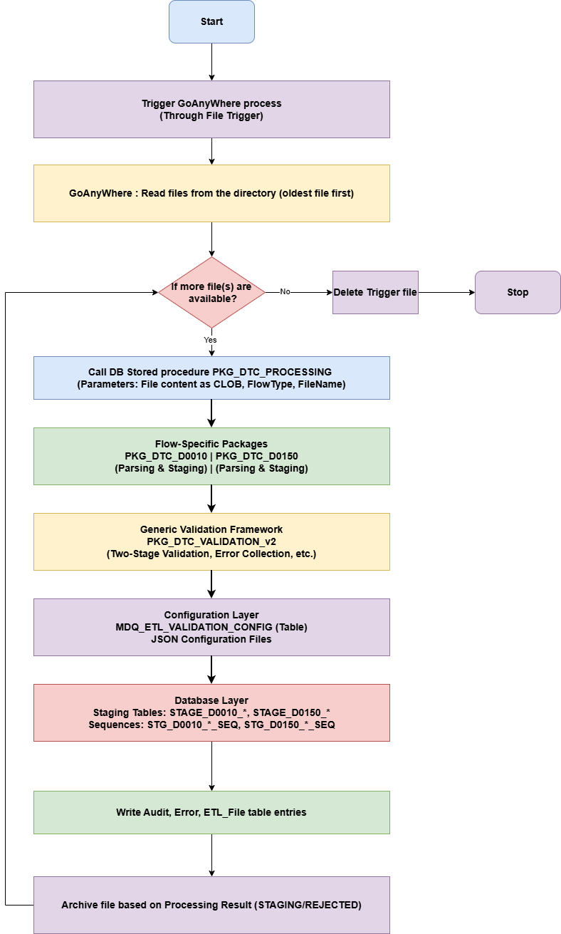

Design Principles
- Separation of Concerns: Validation logic is separated from parsing and staging logic
- Reusability: Generic validation framework is reusable across multiple flow types
- Configuration-Driven: Validation rules are configurable in JSON format
- Two-Stage Validation: Critical file-level validation (Stage 1) and Line by line & group-level validation (Stage 2)
- Partial Acceptance: System can accept valid data even when some groups fail validation (Applicable only for Stage 2 validation)
- Hierarchical Integrity: Parent-child relationships are strictly enforced

Component Design

Package Structure

PKG_DTC_VALIDATION (Generic Validation Package)
Purpose: Provides reusable validation logic for any DTC flow type
Key Functions: -
FN_GET_ACTIVE_CONFIG: Retrieve active validation configuration
FN_SPLIT_FILE_LINES: Split CLOB file into lines
FN_GET_GROUP_ID: Extract group ID from a line
FN_PARSE_HEADER: Parse and extract header fields
FN_PARSE_FOOTER: Parse and extract footer fields
FN_VALIDATE_STAGE1: File-level validation (critical)
FN_VALIDATE_STAGE2: Group-level validation (partial acceptance)
FN_VALIDATE_GROUP_LINE: Validate a single group line
FN_VALIDATE_FIELD: Validate a single field value
ADD_ERROR: Add error to collection
WRITE_ERROR: Write Error information to the MDQ_ETL_ERROR TABLE
WRITE_AUDIT: Write Audit information to the MDQ_ETL_AUDIT TABLE
WRITE_FILE_TABLE: Write information to the MDQ_ETL_FILE TABLE

PKG_DTC_D0010 (D0010 Flow Package)
Purpose: Parse and stage D0010 (Meter Readings) flow files
Key Procedures/Functions: -
PRC_PROCESS_FILE_V2: Main entry point with integrated validation
FN_INSERT_GROUP_026: Insert parent group (MPAN)
PRC_INSERT_GROUP_027: Insert site visit check for MPAN
FN_INSERT_GROUP_028: Insert meter details
PRC_INSERT_GROUP_029: Insert site visit check for meter
FN_INSERT_GROUP_030: Insert meter reading
PRC_INSERT_GROUP_032: Insert read reason
PRC_INSERT_GROUP_033: Insert site visit check for reading

PKG_DTC_D0150 (D0150 Flow Package)
Purpose: Parse and stage D0150 (Non Half Hourly Meter Technical Details) flow files
Key Procedures/Functions:
PRC_PROCESS_FILE_V2: Main entry point with integrated validation
PRC_PROCESS_FILE: Legacy entry point without validation
FN_INSERT_GROUP_288: Insert parent group (MPAN)-yes
PRC_INSERT_GROUP_289: Insert supplier contractor info-yes
FN_INSERT_GROUP_290: Insert meter details -yes
PRC_INSERT_GROUP_291: Insert CT ratio-no
PRC_INSERT_GROUP_293: Insert meter register-yes
PRC_INSERT_GROUP_295: Insert channel details -no
PRC_INSERT_GROUP_296: Insert meter maintenance -no
PRC_INSERT_GROUP_762: Insert MPAN-level maintenance -yes
PRC_INSERT_GROUP_08A: Insert meter removal info-yes

Generic Validation Framework

Two-Stage Validation Approach
The validation framework uses a two-stage approach to balance strictness with flexibility:

Stage 1: File-Level Validation (Critical)
Scope: File structure and integrity
Validations:
1. Header format and mandatory fields
2. Footer format and mandatory fields
3. Record count match (file content vs. footer)
4. Flow count match (parent groups vs. footer)
5. File identifier consistency (header vs. footer)
6. Presence of at least one parent group
Outcome:
- Pass: Proceed to Stage 2
- Fail: Reject entire file, no data staged

Stage 2: Group-Level Validation (Partial Acceptance)
Scope: Individual group and field validation
Validations:
1. Field mandatory check
2. Field length validation (min/max)
3. Data type validation (NUMBER, DATE, DATETIME)
4. Pattern matching (regex)
5. Numeric precision and scale
6. Hierarchical validity propagation
Outcome:
- Pass: All groups staged
- Fail: Only valid parent groups (and their children) staged, invalid groups rejected

Hierarchical Validation Logic
The system maintains hierarchical validity using Boolean flags:
D0010 Example:
v_026_valid := TRUE -- Parent (MPAN)
v_028_valid := TRUE -- Intermediate parent (Meter)
v_030_valid := TRUE -- Intermediate parent (Reading)
When 026 fails:
v_026_valid := FALSE
→ 026 and all descendants rejected
When 028 fails:
v_028_valid := FALSE
→ 028 and its descendants rejected
→ 026 and its direct children (027) still valid
When 030 fails:
v_030_valid := FALSE
→ 030 and its descendants (032, 033) rejected
→ 026, 027, 028, 029 still valid

Field Validation Engine
The field validation engine (FN_VALIDATE_FIELD) performs comprehensive checks:
Validation Steps:
1. Mandatory Check: If field is mandatory and empty → Error
2. Length Check: If length < minLength or > maxLength → Error
3. Data Type Check: - NUMBER: Convert to NUMBER, validate precision/scale - DATE/DATETIME: Convert using format string
4. Pattern Check: Apply regex pattern if specified
5. Precision/Scale Check (for NUMBER): - Count total significant digits - Count decimal places - Validate against precision (total) and scale (decimal)
Example Precision/Scale Validation
-- For value "12345.67" with precision=9, scale=2:
v_integer_part := "12345" -- 5 digits
v_decimal_part := "67" -- 2 digits
v_total_digits := 7 -- OK (< 9)
v_decimal_digits := 2 -- OK (= 2)
-- For value "12345.678" with precision=9, scale=2:
v_decimal_digits := 3 -- ERROR (> 2)

D0010 Flow Design

Data Structure
D0010: Meter Readings
└── 026 (MPAN - Parent)
├── 027 (Site Visit)
└── 028 (Meter)
├── 029 (Site Visit)
└── 030 (Reading)
├── 032 (Read Reason)
└── 033 (Site Visit)

D0150 Flow Design

Data Structure
D0150: Non Half Hourly Meter Technical Details
└── 288 (MPAN - Parent)
├── 289 (Standard Settlement Configuration)
├── 762 (MPAN Maintenance)
├── 290 (Meter Details)
│ ├── 291 (CT Ratio)
│ ├── 293 (Meter Register)
│ ├── 295 (Channel Details)
│ └── 296 (Maintenance)
└── 08A (Meter Removal)

6. Data Model

6.1 D0010 Staging Tables
-- Parent: MPAN
STAGE_D0010_026
├── STG_026_PK (Primary Key)
├── STG_026_FILE_PK (File Reference)
├── STG_026_FILE_REC_NUM (Record Number)
├── STG_026_MPAN (13-digit NUMBER)
└── STG_026_BSC_VLDN_STATUS (VARCHAR2(1))
-- Child of 026: Site Visit
STAGE_D0010_027
├── STG_027_026_PK (Foreign Key → STG_026_PK)
├── STG_027_FILE_REC_NUM
├── STG_027_SITE_VISIT_CHECK (VARCHAR2(2))
└── STG_027_ADD_INFO (VARCHAR2(200))
-- Child of 026: Meter
STAGE_D0010_028
├── STG_028_PK (Primary Key)
├── STG_028_026_PK (Foreign Key → STG_026_PK)
├── STG_028_FILE_REC_NUM
├── STG_028_MTR_ID (VARCHAR2(10))
└── STG_028_READING_TYPE (VARCHAR2(1))
-- Child of 028: Site Visit
STAGE_D0010_029
├── STG_029_028_PK (Foreign Key → STG_028_PK)
├── STG_029_FILE_REC_NUM
├── STG_029_SITE_VISIT_CHECK (VARCHAR2(2))
└── STG_029_ADD_INFO (VARCHAR2(200))
-- Child of 028: Reading
STAGE_D0010_030
├── STG_030_PK (Primary Key)
├── STG_030_028_PK (Foreign Key → STG_028_PK)
├── STG_030_FILE_REC_NUM
├── STG_030_MTR_REG_ID (VARCHAR2(2))
├── STG_030_READ_DTTM (DATE)
├── STG_030_READ_VAL (NUMBER)
├── STG_030_MD_RESET_DTTM (DATE)
├── STG_030_MD_RESET_NUM (NUMBER)
├── STG_030_READ_IND (VARCHAR2(1))
└── STG_030_READING_MTHD (VARCHAR2(1))
-- Child of 030: Read Reason
STAGE_D0010_032
├── STG_032_030_PK (Foreign Key → STG_030_PK)
├── STG_032_FILE_REC_NUM
├── STG_032_READ_REASON_CODE (VARCHAR2(2))
└── STG_032_READ_STATUS (VARCHAR2(1))
-- Child of 030: Site Visit
STAGE_D0010_033
├── STG_033_030_PK (Foreign Key → STG_030_PK)
├── STG_033_FILE_REC_NUM
├── STG_033_SITE_VISIT_CHECK (VARCHAR2(2))
└── STG_033_ADD_INFO (VARCHAR2(200))

6.2 D0150 Staging Tables
-- Parent: MPAN
STAGE_D0150_288
├── STG_288_PK (Primary Key)
├── STG_288_FILE_PK (File Reference)
├── STG_288_FILE_REC_NUM
├── STG_288_MPAN (13-digit NUMBER)
├── STG_288_MSMTD (DATE - Measurement System Transfer Date)
├── STG_288_MC_ID (VARCHAR2(1) - Meter Configuration Id)
└── STG_288_MSES (VARCHAR2(1) - Meter Serial Equipment Status)
-- Child of 288: Supplier Contractor
STAGE_D0150_289
├── STG_289_288_PK (Foreign Key → STG_288_PK)
├── STG_289_FILE_REC_NUM
├── STG_289_SCON_ID (VARCHAR2(4))
├── STG_289_SCON_DT (DATE)
├── STG_289_MSNSFC_ID (VARCHAR2(10))
└── STG_289_MSNSFC_DT (DATE)
-- Child of 288: Meter Details
STAGE_D0150_290
├── STG_290_PK (Primary Key)
├── STG_290_288_PK (Foreign Key → STG_288_PK)
├── STG_290_FILE_REC_NUM
├── STG_290_MTR_ID (VARCHAR2(10))
├── STG_290_MTR_COP (VARCHAR2(3))
├── STG_290_MTR_COP_DISP (NUMBER)
├── STG_290_MTR_CUR_RATING (NUMBER)
└── STG_290_MTR_LOC (VARCHAR2(1))
-- Child of 290: CT Ratio
STAGE_D0150_291
├── STG_291_290_PK (Foreign Key → STG_290_PK)
├── STG_291_FILE_REC_NUM
└── STG_291_CT_RATIO (VARCHAR2(6))
-- Child of 290: Meter Register
STAGE_D0150_293
├── STG_293_290_PK (Foreign Key → STG_290_PK)
├── STG_293_FILE_REC_NUM
├── STG_293_MTR_REG_ID (VARCHAR2(2))
├── STG_293_MTR_REG_TYPE (VARCHAR2(1))
├── STG_293_MQ_ID (VARCHAR2(2))
└── STG_293_MTR_REG_MULTIPLIER (NUMBER(9,2))
-- Child of 290: Channel Details
STAGE_D0150_295
├── STG_295_290_PK (Foreign Key → STG_290_PK)
├── STG_295_FILE_REC_NUM
├── STG_295_CHANNEL_NUM (VARCHAR2(3))
├── STG_295_MQ_ID (VARCHAR2(2))
└── STG_295_PULSE_MULTIPLIER (NUMBER(9,6))
-- Child of 290: Maintenance
STAGE_D0150_296
├── STG_296_290_PK (Foreign Key → STG_290_PK)
├── STG_296_FILE_REC_NUM
├── STG_296_MAINT_DT (DATE)
└── STG_296_MAINT_DESC (VARCHAR2(200))
-- Child of 288: MPAN-level Maintenance
STAGE_D0150_762
├── STG_762_288_PK (Foreign Key → STG_288_PK)
├── STG_762_FILE_REC_NUM
├── STG_762_MAINT_DT (DATE)
└── STG_762_MAINT_DESC (VARCHAR2(200))
-- Child of 288: Meter Removal
STAGE_D0150_08A
├── STG_08A_288_PK (Foreign Key → STG_288_PK)
├── STG_08A_FILE_REC_NUM
├── STG_08A_MTR_ID (VARCHAR2(10))
├── STG_08A_MTR_REMOVAL_DT (DATE)
└── STG_08A_MTR_ASST_PROV_ID (VARCHAR2(4))

6.3 Configuration Table
MDQ_ETL_VALIDATION_CONFIG
├── MEVC_PK (Primary Key)
├── MEVC_FLOW_TYPE (VARCHAR2(10) - e.g., 'D0010', 'D0150')
├── MEVC_CONFIG_VERSION (NUMBER - Configuration version)
├── MEVC_ACTIVE_YN (VARCHAR2(1) - 'Y' or 'N')
├── MEVC_CONFIG_JSON (CLOB - JSON configuration)
├── MEVC_CREATED_DT (DATE)
└── MEVC_UPDATED_DT (DATE)

Process Flows

Overall Process Flow
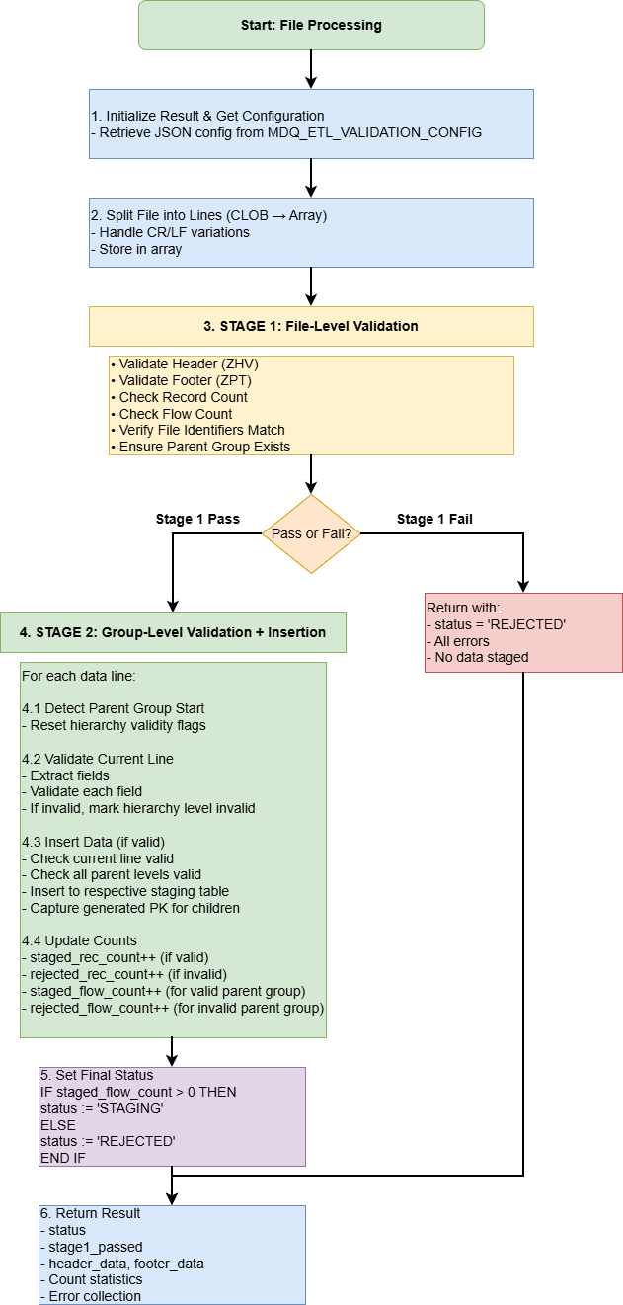

Stage 1 Validation Flow
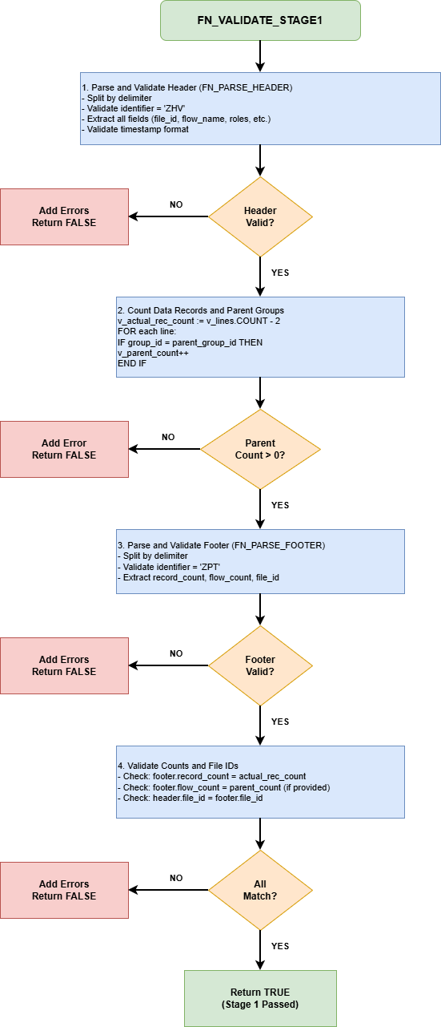

Stage 2 Validation Flow (Per Line)
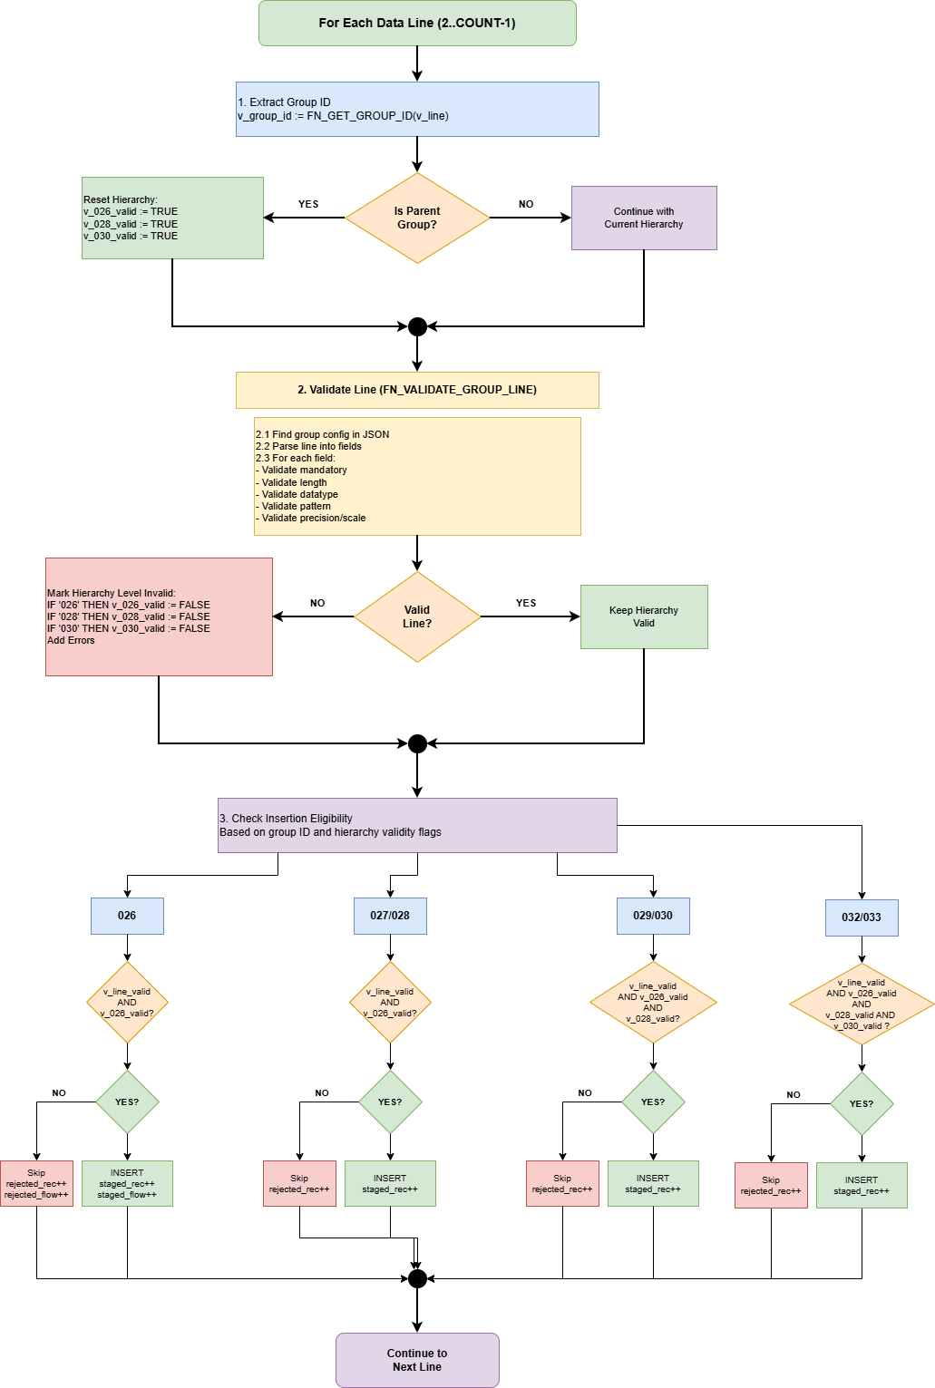
Note: The process above illustrates the generic Stage 2 validation process using D0010 as an example when it comes to specific group names. Variable names (eg. v_026_valid) will be different for other flows (say v_290_valid in case of D0150)

Hierarchical Validity Propagation
D0010 Example: Invalid Group 028
File Content:
026|... ← Valid
027|... ← Valid (child of 026)
028|INVALID|... ← INVALID (child of 026)
029|... ← Would be rejected (child of 028)
030|... ← Would be rejected (child of 028)
032|... ← Would be rejected (grandchild of 028)
Validation Results:
Line Group Line 026 028 030 Action
Valid Valid Valid Valid
──── ───── ──── ───── ───── ───── ─────────────
2 026 TRUE TRUE TRUE TRUE INSERT 026
3 027 TRUE TRUE TRUE TRUE INSERT 027
4 028 FALSE TRUE FALSE TRUE REJECT 028, set v_028_valid=FALSE
5 029 TRUE TRUE FALSE TRUE REJECT 029 (v_028_valid=FALSE)
6 030 TRUE TRUE FALSE TRUE REJECT 030 (v_028_valid=FALSE)
7 032 TRUE TRUE FALSE FALSE REJECT 032 (v_028_valid=FALSE)
Result:
- 026 and 027 are staged
- 028, 029, 030, 032 are rejected

Error Handling

Error Codes

Error Code | Error Nature | Error Text Template | Example | Stage
HEADER_MISSING | Invalid Header Identifier | Invalid header identifier. Expected {header_id} but got {actual_value} | Invalid header identifier. Expected ZHV but got ZHX | Stage 1
FIELD_MANDATORY | Header Field Validation Failed | (Various field-level errors) | Header field fileIdentifier is mandatory but empty | Stage 1
(Exception) | Header Validation Exception | Error validating header: {SQLERRM} | Error validating header: ORA-06502: PL/SQL: numeric or value error | Stage 1
FOOTER_MISSING | Invalid Footer Identifier | Invalid footer identifier. Expected {footer_id} but got {actual_value} | Invalid footer identifier. Expected ZPT but got ZPX | Stage 1
FIELD_MANDATORY | Footer Field Validation Failed | (Various field-level errors) | Footer field recordCount is mandatory but empty | Stage 1
(Exception) | Footer Validation Exception | Error validating footer: {SQLERRM} | Error validating footer: ORA-06502: PL/SQL: numeric or value error | Stage 1
(Exception) | File Empty | File content is empty | File content is empty | Stage 1
FIELD_DATATYPE | Invalid Timestamp Format | Invalid header timestamp format: {timestamp_value} | Invalid header timestamp format: 2026013012345 | Stage 1
(Exception) | Header Parse Exception | Error parsing header: {SQLERRM} | Error parsing header: ORA-06502: PL/SQL: numeric or value error | Stage 1
FIELD_DATATYPE | Invalid Record Count | Invalid record count: {value} | Invalid record count: ABC123 | Stage 1
FIELD_DATATYPE | Invalid Flow Count | Invalid flow count: {value} | Invalid flow count: XYZ | Stage 1
(Exception) | Footer Parse Exception | Error parsing footer: {SQLERRM} | Error parsing footer: ORA-06502: PL/SQL: numeric or value error | Stage 1
RECORD_COUNT_MISMATCH | Record Count Mismatch | Record count mismatch. Expected {expected_count} but footer shows {footer_count} | Record count mismatch. Expected 150 but footer shows 148 | Stage 1
FLOW_COUNT_MISMATCH | Flow Count Mismatch | Flow count mismatch. Found {actual_count} parent groups but footer shows {footer_count} | Flow count mismatch. Found 12 parent groups but footer shows 10 | Stage 1
FILE_ID_MISMATCH | File Identifier Mismatch | File identifier mismatch between header ({header_id}) and footer ({footer_id}) | File identifier mismatch between header (FILE123) and footer (FILE124) | Stage 1
STAGE1_ERROR | Stage 1 Exception | Stage 1 validation error: {SQLERRM} | Stage 1 validation error: ORA-01722: invalid number | Stage 1
CONFIG_NOT_FOUND | No Active Config Found | No active validation configuration found for flow type {flow_type} | No active validation configuration found for flow type D0150 | Stage 1
FILE_TOO_SHORT | File Too Short | File must have at least header, one data line and footer | File must have at least header, one data line and footer | Stage 1
UNKNOWN_GROUP | Unknown Group Identifier | Unknown group identifier: {group_id} | Unknown group identifier: 999 | Stage 2
(Exception) | Group Validation Exception | Error validating group {group_id}: {SQLERRM} | Error validating group 026: ORA-01722: invalid number | Stage 2
STAGE2_ERROR | Stage 2 Exception | Stage 2 validation error: {SQLERRM} | Stage 2 validation error: ORA-06502: PL/SQL: numeric or value error | Stage 2
FIELD_MANDATORY | Mandatory Field Empty | Field {field_name} is mandatory but empty | Field MPAN is mandatory but is not populated | Stage 2
FIELD_LENGTH | Length Below Minimum | Field {field_name} length {actual_length} is less than minimum {min_length} | Field MeterId length 0 is less than minimum 1 | Stage 2
FIELD_LENGTH | Length Exceeds Maximum | Field {field_name} length {actual_length} exceeds maximum {max_length} | Field AdditionalInfo length 250 exceeds maximum 200 | Stage 2
FIELD_DATATYPE | Invalid Number Format | Field {field_name} value "{field_value}" is not a valid number | Field ReadValue value "ABC123" is not a valid number | Stage 2
FIELD_DATATYPE | Decimal Scale Exceeded | Field {field_name} has {actual_decimal_digits} decimal places but scale is {configured_scale} | Field MeterMultiplier has 3 decimal places but scale is 2 | Stage 2
FIELD_DATATYPE | Precision Exceeded (Decimal) | Field {field_name} has {actual_total_digits} total digits but precision is {configured_precision} | Field ReadValue has 12 total digits but precision is 9 | Stage 2
FIELD_DATATYPE | Precision Exceeded (Integer) | Field {field_name} has {actual_digits} digits but max allowed is {precision - scale} (precision {precision} - scale {scale}) | Field MPAN has 14 digits but max allowed is 13 (precision 13 - scale 0) | Stage 2
FIELD_DATATYPE | Invalid Date Format | Field {field_name} value "{field_value}" is not a valid date with format {format} | Field ReadDateTime value "20260230" is not a valid date with format YYYYMMDD | Stage 2
FIELD_PATTERN | Pattern Mismatch | Field {field_name} value "{field_value}" does not match pattern {pattern} | Field FlowName value "X0150001" does not match pattern ^D0150\d{3}$ | Stage 2
(Exception) | Unexpected Field Validation Error | Error validating field {field_name}: {SQLERRM} | Error validating field MeterId: ORA-01722: invalid number | Stage 2
(Exception) | File Validation Exception | Unexpected error in file validation: {SQLERRM} | Unexpected error in file validation: ORA-01722: invalid number | Stage 2

Configuration Management

Configuration Retrieval
Function: PKG_DTC_VALIDATION.FN_GET_ACTIVE_CONFIG
FUNCTION FN_GET_ACTIVE_CONFIG(
p_flow_type IN VARCHAR2
) RETURN CLOB IS
v_config_json CLOB;
BEGIN
SELECT MEVC_CONFIG_JSON
INTO v_config_json
FROM MDQ_ETL_VALIDATION_CONFIG
WHERE MEVC_FLOW_TYPE = p_flow_type
AND MEVC_ACTIVE_YN = 'Y'
AND ROWNUM = 1
ORDER BY MEVC_VERSION DESC;
RETURN v_config_json;
EXCEPTION
WHEN NO_DATA_FOUND THEN
RETURN NULL;
END;

Validation Configuration Structure
See separate document: CONFIG_STRUCTURE.docx

EWAY Changes

There will be changes in EWAY to store D0010 and D0150 files into a different path within DTC directory of Datastage server (say <PROJECT_FOLDER_PREFIX/DTC/inbox_gaw>. This is to enable Datastage and GoAnywhere to look at different folders and avoid any file contention issues. Also, Datastage staging process will be enhanced to allow it to place a trigger file (1 byte dummy file) into a file trigger directory (say <PROJECT_FOLDER_PREFIX/gaw_file_trigger). This is a temporary arrangement. Once all Datastage staging jobs move to GoAnyWhere/Stored Procedures, there will be no need for this trigger file mechanism, as the scheduling can be managed in GoAnyWhere directly.

Steps to add a new D-Flow in this framework
Overview
From a package perspective, adding a new D-Flow requires two new packages and one change to an existing package.

New packages to create:
PKG_DTC_D{XXXX}. pks – package specification
PKG_DTC_D{XXXX}. pkb – package body

Existing package to modify:
PKG_DTC_PROCESSING.pkb – add one ELSIF branch to route the new flow type

PKG_DTC_VALIDATION and PKG_DTC_COMMON require no changes. They are generic and driven entirely by the JSON validation config stored in MDQ_ETL_VALIDATION_CONFIG.

Prerequisite – Validation Configuration
Before compiling the new package, insert a JSON config row into MDQ_ETL_VALIDATION_CONFIG with MEVC_ACTIVE_YN = 'Y'. PKG_DTC_VALIDATION reads this at runtime — no code change to the validation package is ever needed.

The JSON must define:
"flowType" – must exactly match the value passed as p_flow_type (e.g. "D0302")
"header" – ZHV field rules (position, mandatory, dataType, pattern)
"footer" – ZPT field rules (recordCount, flowCount)
"groups"[] – one entry per group:
groupId, parentGroup (null for root group), tableName, fields []

D0302 group hierarchy in config:
68C parentGroup: null (root parent – MPAN + Registration Date)
69C parentGroup: "68C” (leaf – Customer Details)
70C parentGroup: "68C” (leaf – Mail Address)
15J parentGroup: "68C” (intermediate parent – Contact Details)
16J parentGroup: "15J” (leaf – Phone / Fax)
17J parentGroup: "15J" (leaf – Email)

Step 1 – Create the Package Specification (PKG_DTC_D{XXXX}.pks)
Declare one procedure and one function or procedure per group. Three declaration patterns are used:
PRC_PROCESS_FILE_V2 – framework entry point. Signature is fixed and must match exactly:
PROCEDURE PRC_PROCESS_FILE_V2(
p_file_pk IN NUMBER,
p_lines IN DBMS_SQL.VARCHAR2A,
p_flow_type IN VARCHAR2,
p_stage1_data IN PKG_DTC_VALIDATION.t_file_validation_result,
p_result OUT PKG_DTC_VALIDATION.t_file_validation_result);

FN_INSERT_GROUP_{GroupId} – for every group that has children (returns its own PK):

-- Root parent (no p_parent_pk needed)
FUNCTION FN_INSERT_GROUP_68C(p_file_pk IN NUMBER,
p_fields IN PKG_DTC_COMMON.t_fields_array, p_rec_num IN NUMBER) RETURN NUMBER;

-- Intermediate parent (takes parent PK as input)
FUNCTION FN_INSERT_GROUP_15J(p_parent_pk IN NUMBER, p_file_pk IN NUMBER,
p_fields IN PKG_DTC_COMMON.t_fields_array, p_rec_num IN NUMBER) RETURN NUMBER;

PRC_INSERT_GROUP_{GroupId} – for every leaf group (no return value):
PROCEDURE PRC_INSERT_GROUP_69C(p_parent_pk IN NUMBER, p_file_pk IN NUMBER, p_fields IN PKG_DTC_COMMON.t_fields_array, p_rec_num IN NUMBER);

Step 2 – Create the Package Body (PKG_DTC_D{XXXX}.pkb)

Implement three routine types. Refer to PKG_DTC_D0302.pkb as the reference
implementation.

FN_INSERT_GROUP_{GroupId} (parent groups):
1. Parse: v_fields := PKG_DTC_COMMON.FN_PARSE_LINE(p_line)
2. Insert: STG_D0302_{GroupId}_SEQ.NEXTVAL as PK,
FN_CONVERT_DATE / FN_CONVERT_NUMBER for typed columns,
field index is 1-based; field(1) = group ID, data starts at field(2)
3. Return: RETURNING STG_{GroupId}_PK INTO v_pk; RETURN v_pk;

PRC_INSERT_GROUP_{GroupId} (leaf groups):
Same parse pattern. INSERT with p_parent_pk as the FK column. No RETURN.

PRC_PROCESS_FILE_V2 (main dispatch loop):
Declare one PK-tracking variable per parent group level:
v_parent_68C_pk NUMBER; v_parent_15J_pk NUMBER;

Declare one validity flag per level:
v_68C_valid BOOLEAN; v_15J_valid BOOLEAN;
Loop lines 2 .. p_lines.COUNT-1 (line 1 = ZHV header, last line = ZPT footer)
Skip rejected lines: EXIT when FN_IS_LINE_IN_VALID_GROUP returns FALSE
Get group ID: v_group_id := PKG_DTC_COMMON.FN_GET_GROUP_ID(v_line)

Dispatch:
IF v_group_id = '68C' THEN v_parent_68C_pk := FN_INSERT_GROUP_68C(...)
ELSIF v_group_id = '69C' THEN PRC_INSERT_GROUP_69C(v_parent_68C_pk,...)
ELSIF v_group_id = '15J' THEN v_parent_15J_pk := FN_INSERT_GROUP_15J(v_parent_68C_pk,...)
ELSIF v_group_id = '16J' THEN PRC_INSERT_GROUP_16J(v_parent_15J_pk,...)
Grandchild guard: only insert 16J / 17J when v_68C_valid AND v_15J_valid are both TRUE
Increment p_result.staged_rec_count on success, rejected_rec_count on skip / exception

Step 3 – Register the New Flow in PKG_DTC_PROCESSING.pkb
This is the only change to an existing package. Inside PRC_PROCESS_FILE, add one ELSIF after the last registered flow (currently D0150):
ELSIF p_flow_type = 'D0302' THEN
PKG_DTC_D0302.PRC_PROCESS_FILE_V2(
p_file_pk => v_file_pk,
p_lines => v_split_lines,
p_flow_type => p_flow_type,
p_stage1_data => v_validation_result,
p_result => v_staging_result);

All audit creation, error logging, file status updates, and the unsupported-flow error path are already generic in PKG_DTC_PROCESSING no further changes needed.

Compile Order
Always compile the spec before the body. The JSON config must be inserted before the first runtime call.
1. Insert JSON config into MDQ_ETL_VALIDATION_CONFIG (MEVC_ACTIVE_YN = 'Y')
2. Compile PKG_DTC_D0302.pks (spec first)
3. Compile PKG_DTC_D0302.pkb (body references tables and sequences)
4. Recompile PKG_DTC_PROCESSING.pkb (to activate the new ELSIF branch)

Technical Management Guide for BAU App Support team
Overview of Key Tables
Three tables are used to monitor and investigate file processing.
Table | Purpose
MDQ_ETL_FILE | One row per file processed. First place to check status.
MDQ_ETL_AUDIT | Two rows per file — parent job PKG_DTC_PROCESSING and child job PKG_DTC_D{XXXX}.
MDQ_ETL_ERROR | One row per validation or processing error. Linked via ERR_FILE_PK.
MDQ_ETL_VALIDATION_CONFIG | JSON validation rules per flow type. Read-only for support.

AUD_JOB_STATUS values (MDQ_ETL_AUDIT):
AUD_JOB_STATUS | Meaning
RUNNING | Still in progress.
SUCCESSFUL | All data staged cleanly.
WARNING | Some records/groups rejected, some staged.
ERROR | All records rejected or critical validation failure.
ABORTED | Unexpected exception — escalate to developer.

Step 1 – Check File Status
Start here for any reported issue. Use the file name to find the file record:
SELECT FIL_FILE_PK, FIL_FILE_NAME, FIL_FILE_TYPE,
FIL_LOAD_STUS, FIL_STG_LOAD_DTTM,
FIL_REC_CNT, FIL_STG_REC_CNT,
FIL_STG_REJ_FLOW_CNT, FIL_STG_REJ_REC_CNT
FROM MDQ_ETL_FILE
WHERE FIL_FILE_NAME = '<filename>'
ORDER BY FIL_CR_DTTM DESC;

Step 2 – Check Audit Trail
Two audit rows are expected per file — one for the parent job and one for the flow-specific job:
SELECT AUD_JOB_NAME, AUD_PR_JOB_NAME, AUD_JOB_STATUS,
AUD_JOB_START_DTTM, AUD_JOB_END_DTTM,
AUD_REC_PROC_CNT, AUD_REC_SUCC_CNT,
AUD_REC_FAIL_CNT, AUD_REC_REJ_CNT
FROM MDQ_ETL_AUDIT
WHERE AUD_FILE_PK = <FIL_FILE_PK>
ORDER BY AUD_JOB_START_DTTM;

Step 3 – Check Errors
ERR_FILE_COL shows which field failed. ERR_FILE_COL_VAL shows the bad value. ERR_MSG_TEXT gives the reason:
SELECT ERR_FILE_ROW_NUM, ERR_FILE_COL,
ERR_FILE_COL_VAL, ERR_MSG_TEXT, ERR_TIMESTAMP
FROM MDQ_ETL_ERROR
WHERE ERR_FILE_PK = <FIL_FILE_PK>
ORDER BY ERR_FILE_ROW_NUM;

Step 4 – Check All Files for Today
Use this query to get a summary of all files processed today:
SELECT FIL_FILE_NAME, FIL_FILE_TYPE, FIL_LOAD_STUS,
FIL_REC_CNT, FIL_STG_REC_CNT, FIL_STG_REJ_REC_CNT,
FIL_STG_LOAD_DTTM
FROM MDQ_ETL_FILE
WHERE TRUNC(FIL_CR_DTTM) = TRUNC(SYSDATE)
ORDER BY FIL_CR_DTTM DESC;
Validation Config Check (Read Only)
Only one row per flow type should have MEVC_ACTIVE_YN = 'Y'. Never update this table directly.
SELECT MEVC_FLOW_TYPE, MEVC_CONFIG_VERSION,
MEVC_ACTIVE_YN, MEVC_CR_DTTM, MEVC_NOTES
FROM MDQ_ETL_VALIDATION_CONFIG
ORDER BY MEVC_FLOW_TYPE;

